### 5.2b Classwork: Scaling Triangles

**Activity 1:** Below is an image of a triangle. On the first grid provided, draw a triangle with sides lengths TWICE as long as this image (label the new vertices D, E, F) and on the other grid draw a triangle with side lengths HALF as long as this image (label the new vertices G, H, I.)

1. Describe the method you used to double the length of each side.
2. Describe the method you used to make each side have a length half the length of the original.
3. Do you think the angles of the new triangles are the same or different than the original triangle? Explain.

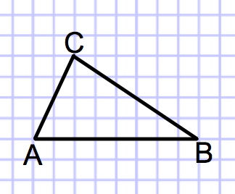

Sides that are twice as long as the image above. Sides that are half as long as the image above.

 

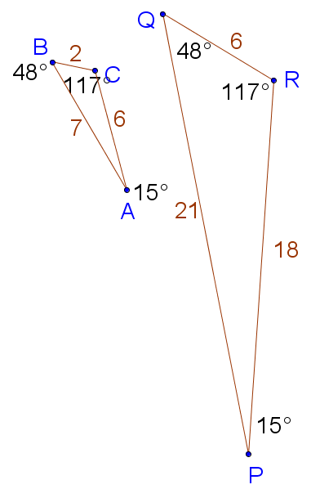2.

Which sides and angles correspond to each other? List corresponding angles and sides:

a) Describe how these triangles are similar and different:

b) What do you notice about the lengths of the sides of the two triangles?

1. Find the ratios for the lengths of the given sides.



|  |  |
| --- | --- |
| a)  to | b) |
| c) | d) Perimeter of  to Perimeter of |
| e)  to | f) to |
| g)to | h) to |
| i) to | j) to |

1. Some of the ratios above make comparisons of measurements in the **same triangle.** Other ratios make comparisons of measurements of corresponding parts of **two different triangles.** Put a star by the ratios that compare parts of two different triangles. What do you notice?
2. Since the corresponding parts have the same ratio, there is a **scale factor** from  to . The scale factor is the number you would multiply a length in  to get the corresponding length in . What is the scale factor from to ? Explain how you arrived at your answer.
3. What is the scale factor from to ?
4. What is the mathematical relationship between the scale factor of  to  and the scale factor of to ?

1. The scale factors from  to is an *enlarging* scale factor, and the other is a *reducing* scale factor. What would be the scale factor to keep a figure the *same size?*
2. Use a straight edge and protractor to construct  then construct a new triangle, , that is the same shape as , but the scale factor from to  is 2.

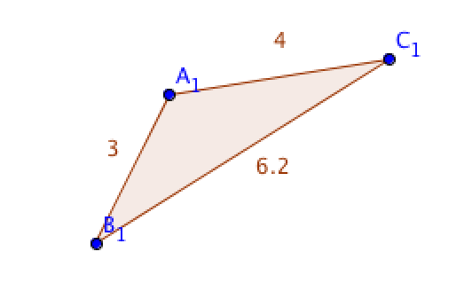

1. The ratio of  to  is 5:4. If  is 15, what is the length of  ? You may need to draw a diagram.