5.3a Homework: How Many Diameters Does it Take to Wrap Around a Circle?
- Identify 3 circular objects around the house (canned foods, door knobs, cups, etc.). Find the measure of each object’s diameter and then calculate its circumference. Put your results in the table below:

Description of item | Diameter (measured) | Circumference (calculated) | Ratio of C : d (calculated) to the nearest hundredth

- What is the exact ratio of the circumference to the diameter of every circle?

- If the radius of a circle is 18 miles,
  - What is the measure of the diameter?

  - What is the measure of the circumference, exactly in terms of pi?

  - What is the approximate measure of the circumference, to the nearest tenth of a mile?

- For each of the three circles below, calculate the circumference. Express your answer both in terms of pi, and also as an approximation to the nearest tenth.
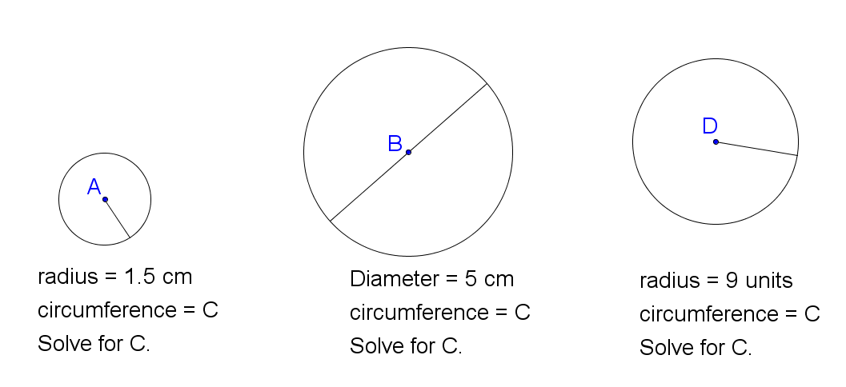

The decimal for π starts with 3.141592653589… Which fraction is closest to π? (Note: there is no fraction that is exactly equal to π.)

$$a) 3\frac{1}{4}$$ | $$b) 3\frac{1}{5}$$ | $$c) 3\frac{1}{7}$$ | $$d) 3\frac{1}{6}$$ | $$e) 3\frac{1}{8}$$

- If the circumference of a circle is $20π$ feet, which of the following statements are true? Rewrite false statements to make them true.
  - The circumference of the circle is exactly 62.8 feet.
  - The diameter of the circle is 20 feet.
  - The radius of the circle is 20 feet.
  - The ratio of circumference : diameter of the circle is $π$.
  - The radius of the circle is twice the diameter.

- The circumference of 5 objects is given. Calculate the diameter of each object, to the nearest tenth of a unit.
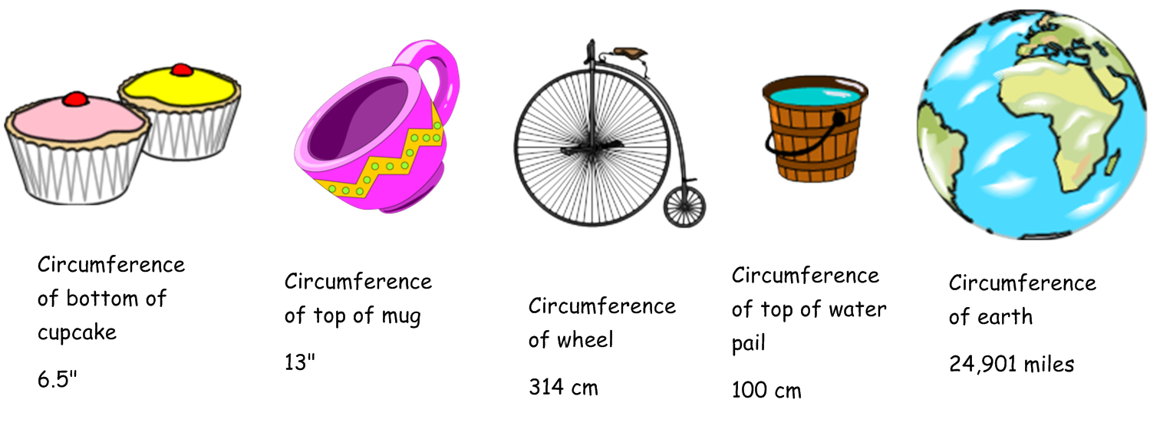

- The diameter or radius of 5 objects is given. Calculate the circumference of each object, to the nearest tenth of a unit.
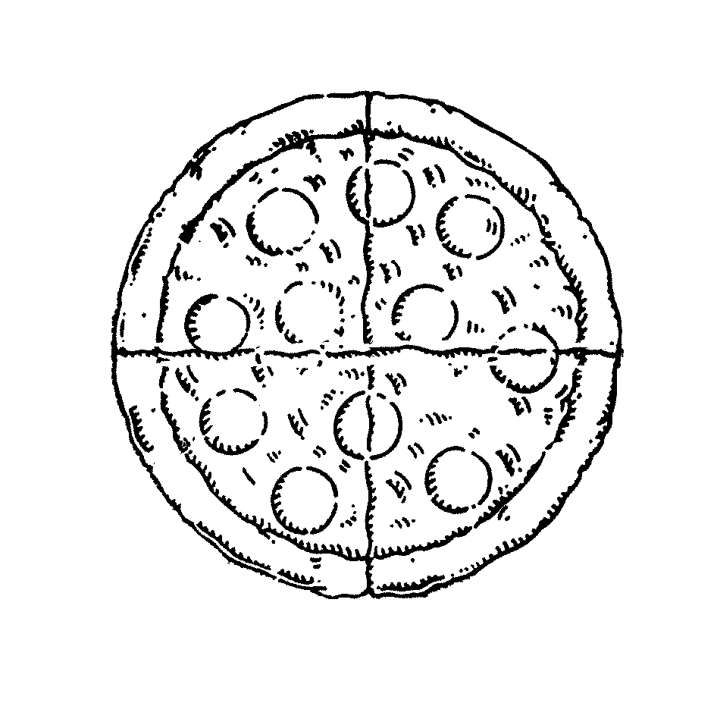
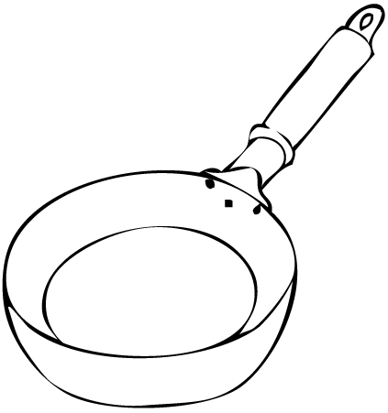
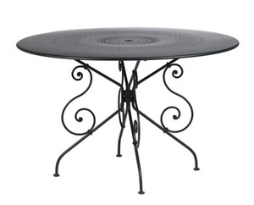
Diameter of pizza
16”
Diameter of
rim of a drum
24”
Diameter of
coin
5 cm
Radius of
frying pan
5.5”
Radius of
table top
2’

