5.3b Area of a Circle

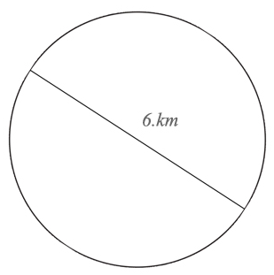
- Calculate the area of each circle. Express your answer both exactly (in terms of pi) and approximately, to the nearest tenth of a unit.

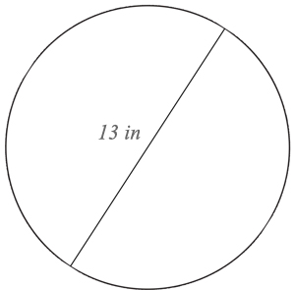

- The strongest winds in Hurricane Katrina extended 30 miles in all directions from the center of the hurricane.
  - Draw a diagram of the situation.

  - What is the area that felt the strongest winds?

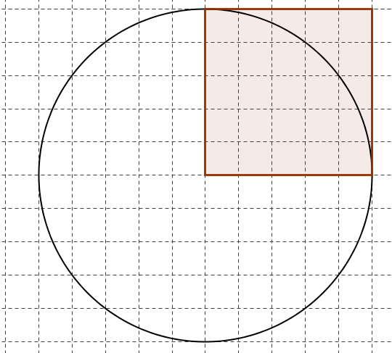
- By calculating the areas of the square and the circle in the diagram, determine how many times larger in area the circle is than the square.

- A circle with radius 8 centimeters is enlarged so its radius is now 24 centimeters.
  - By what scale factor did the circumference increase? Show your work or justify your answer.

  - By what scale factor did the area increase? Show your work or justify your answer.

  - Explain why this makes sense, using what you know about scale factor.

- How many circles of radius 1” could fit in a circle with radius 5” (if you could rearrange the area of the circles of radius 1 in such a way that you completely fill in the circle of radius 5)? Justify your answer.

- The area of 5 objects is given. Calculate the radius of each object’s surface, to the nearest hundredth of a unit.
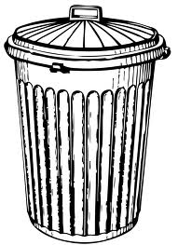
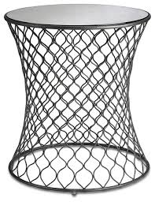
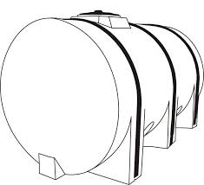
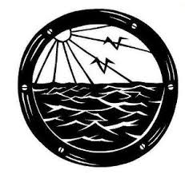

Area of round area rug
153.86 ft²

Area of wicker table top
28.26 ft²

Area of base
of trash can
12.56 ft²
Area of side of a water tank
153.86 ft²

Area of a glass in a porthole 3.14 ft²

Exit Ticket:
What I might need some more help with:
How I feel about scale factor:

