5.4a Homework: Special Angle Relationships
- Find at least one example of each angle relationship in the diagram. Name the angle pairs below, and highlight the pairs of angles in the diagram, using a different color for each relationship. 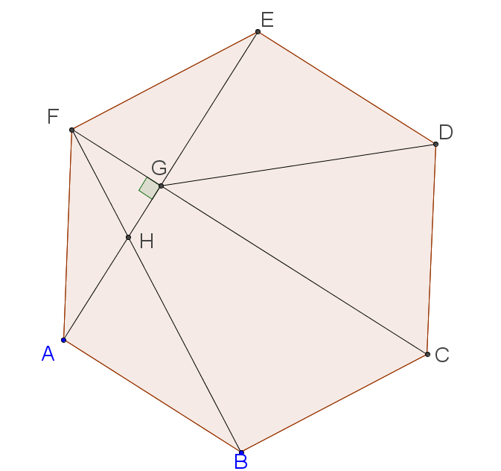.
- Vertical angles

- Supplementary angles

- Complementary angles

- For each figure of two intersecting lines, calculate the three missing measures, justifying your answer.
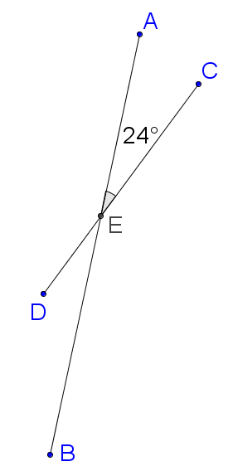

Angle | Measure of angle | Justification
$$∠CEB$$
$$∠DEA$$
$$∠BED$$

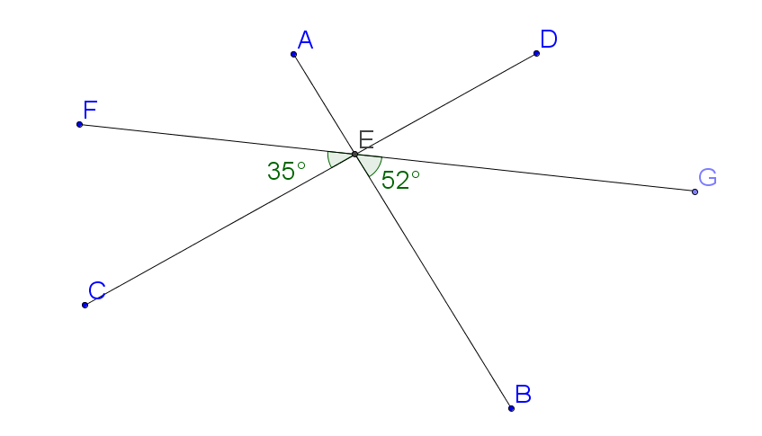
- For the figure formed by three intersecting lines, calculate the four missing measures, justifying your answer.

Angle | $$∠AEF$$ | $$∠AEC$$ | $$∠AED$$ | $$∠DEG$$ | $$∠CEB$$ | $$∠FEG$$
Measure | $$52°$$
Justification | Vertical to $∠GEB$

