8.1a Perimeter and Area Problem Solving

Answer each of the questions below.
- What is the least number of tiles you can add to the figure below to create a shape with a perimeter of 16? Note: When adding a tile, the new tile must share at least one side with the original shape; each tile is 1 unit by 1 unit.

- Use the original figure given above to answer a-d. Draw your answers. Note, an answer of just “yes” or “no” is not sufficient. Use pictures or words to justify your answer.

- Can you add a tile to this figure to increase the perimeter by 1? If so, how?

- Can you add a tile to this figure to increase the perimeter by 2? If so, how?

- Can you add a tile to this figure to increase the perimeter by 3? If so, how?

- Can you add a tile to this figure so that the perimeter doesn’t change? If so, how?

- Can you make more than one shape with the same perimeter, but different areas? Show your ideas with grid paper.

- Can you make more than one shape with the same area, but different perimeters? Show your ideas with grid paper.

- If you pick any whole number between 12 and 24, use that many unit tiles, can you make a shape where the area and perimeter are equal? Show your ideas.

Spiral Review

- Find the area of each of the following shapes:
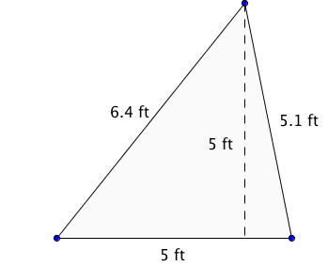 | 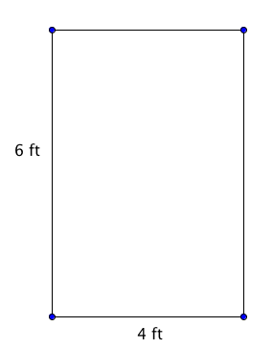
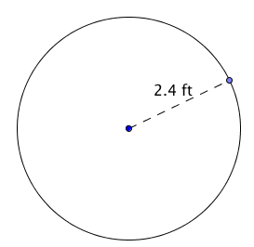 | 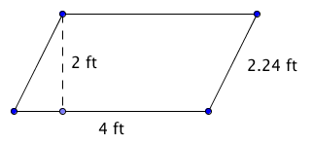

- Solve: −8 < −3m + 10

- Solve: –12 > 3x

- A website says that the odds of Mr. and Mrs. Durrand having a baby with blue or hazel eyes is 50:50. Describe a simulation that models the color of eyes their baby will have.

- Write $\frac{3}{5}$ as a percent and decimal.

