1. Determine if the following side lengths will make a triangle. Explain why or why not.
   1. 2, 5, 7
   2. 33, 93.2, 70
2. Determine if the given angles will make a triangle. Explain why or why not.
   1. Angles 25**°**, 70**°**, 95**°**
   2. Angles 30**°**, 40**°**, 20**°**
3. In each of the following, what is the scale factor that takes  to ?

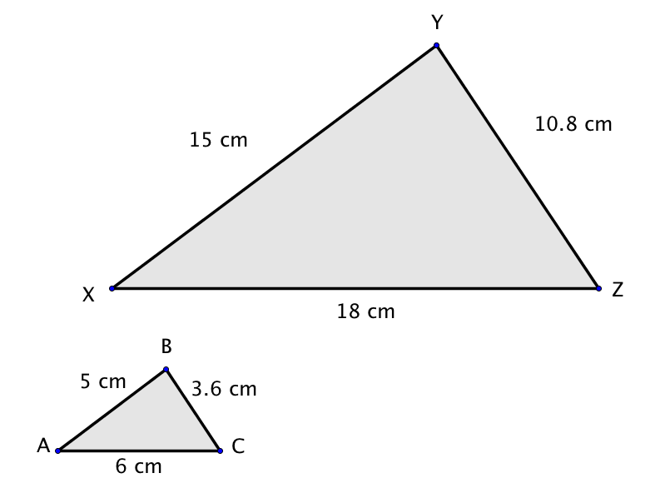

1. Answer the following question using proportional reasoning.
   * + 1. Carlos is reading a map of his town. The scale says 1 in = 4 miles. The distance from his house to the school is  in. on the map. If Carlos wants to walk to school from his house, how far will he have to walk?
2. Use the given information to find the missing information. Give each answer exactly and rounded to the nearest hundredth unit.
   1. Radius: 2 m

Circumference: ____________

* 1. Diameter: 2 m

Circumference: ____________

* 1. Radius: 5.5 in

Area: ____________

* 1. Diameter: 40 in

Area: ____________

* 1. Circumference: 69.08 cm

Diameter: ____________

* 1. Area: 153.86 cm2

Radius: ____________

1. Fill in the missing angle measurements in the table, and give a justification for each measurement.

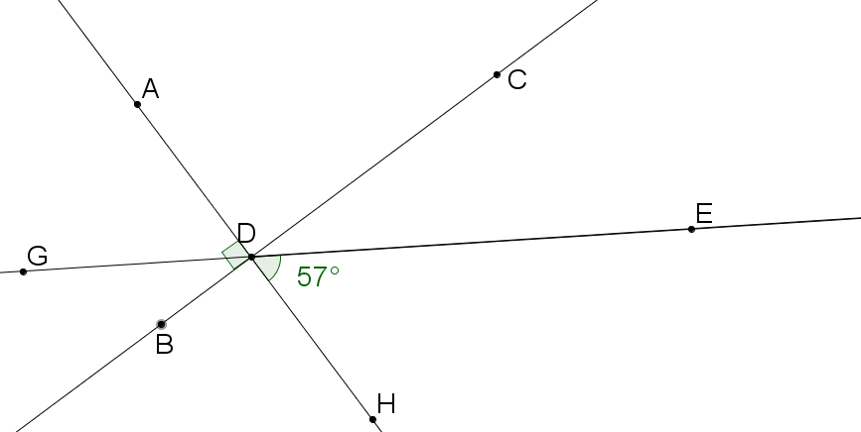

|  |  |  |  |  |  |  |
| --- | --- | --- | --- | --- | --- | --- |
| **Angle** | $$∠ADG$$ | $$∠GDB$$ | $$∠BDH$$ | $$∠CDH$$ | $$∠CDE$$ | $$∠CDA$$ |
| **Measure** | $$57°$$ |  |  |  |  |  |
| **Justification** | Vertical to $∠EDH$ |  |  |  |  |  |

Mark the following statements that are true for you:

__________I can label the radius, diameter, and circumference of a circle.

__________I can use the radius or diameter of a circle to find the circumference of a circle.

__________I can find the area of a circle.

__________I can identify supplementary, complementary and vertical angles.

__________I can solve problems using supplementary, complementary and vertical angles.

__________I can classify triangles as acute, right, obtuse or equilateral.

__________I can use the Angle Theorem of triangles to find the value of missing angles.

*These are the skills you need to know how to do at the end of this chapter.

**Exit Ticket:**

**What I might need some more help with:**

**How I feel about this chapter:**

  