1. The two triangles below are scaled versions of each other. Use a protractor to find the measure of each of the angles of the two triangles below.



1. What is the ratio of  to ? What is the scale factor that takes  to ?
2. Which of the following proportions would be valid for finding the length of? Circle all that apply.
   1. 
   2. 
   3. 
   4. 
3. Write different proportions that could be used to solve for the length of . Solve your proportion.
4. Write and solve a proportion to find the length of  .

### Three Measurements

Preparation for task: included angles.

1. Circle all the triangles with side lengths 8 and 5 and an *included angle* of .

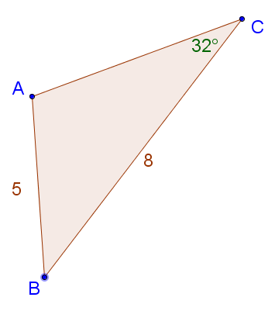  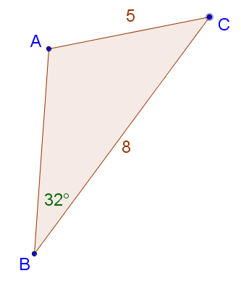

1. Circle all the triangles with side lengths 4 and 3, with a *non-included angle* of  adjacent to the side with length 3.

  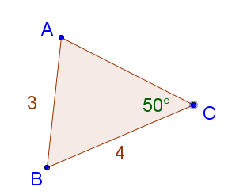 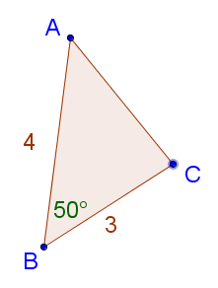

1. Circle all the triangles with two angles  and  with an *included side* of 6 units.

**Discussion questions:** What if you only have three pieces of information about a triangle, like two angle measurements and one side length? Is it possible to create more than one unique triangle with that information?



****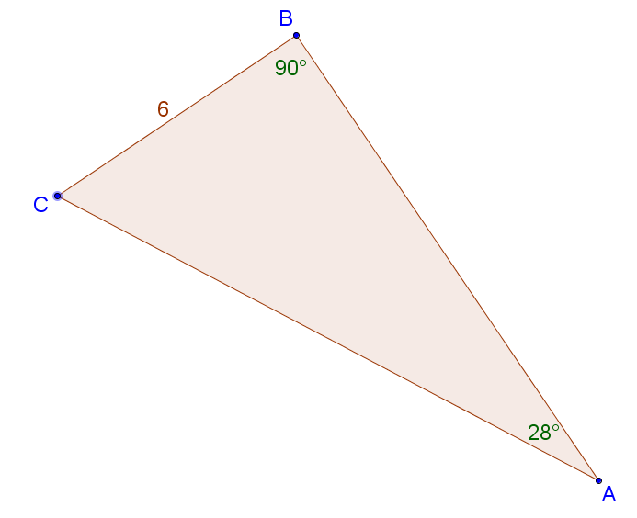

Materials: GeoGebra and 5.2 GeoGebra files