5.4b Classwork: Circles, Angles, and Scaling
Examine the figures below. $\overline{BC}$ has a length of 5 units.

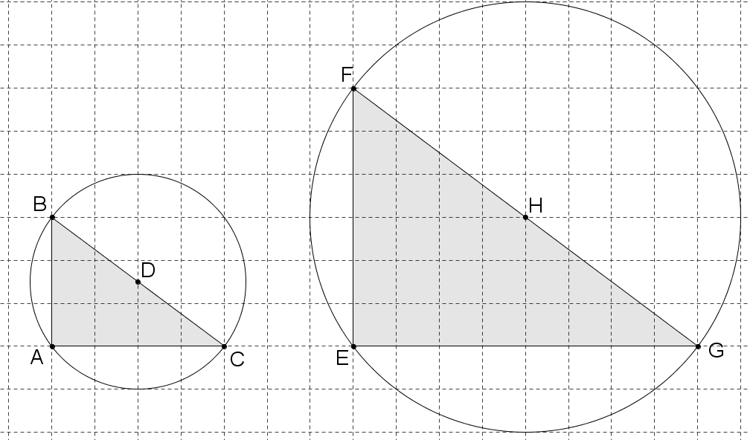

- Write a complete sentence explaining why the figures are scale drawings of each other. You may use a protractor. Use words like corresponding angles, scale factor, corresponding sides, circle.

- Remember that you have been given that $\overline{BC}$ has length 5. What is the radius of each circle? Justify your answer.

- Calculate the area of each triangle.

- Classify the triangles by their sides and angles.

- Name two pairs of complementary angles in the figures.

- What is the area of each circle?

- How many of the smaller circle would fit inside the bigger circle, if you could put all the area in without overlapping and with no empty space?

- What is the circumference of each circle?

- How many of the circumferences of the smaller circle equal the bigger circumference?

- Fill in the blanks: When you enlarge a figure with a scale factor of two, the side lengths and circumference ____________, the areas _______________, and the angles ________________.

- Follow the steps below to create another figure in the space below:
  - Make a dot for the center of a circle, and use a compass to construct a circle around that dot.
  - Use a straightedge to draw in a diameter with endpoints labeled A and B.
  - Choose any point on the edge of the circle, and label it C.
  - Draw in segments AC and BC so you can see a triangle ABC inscribed in the circle.
  - Measure the angles in the triangle, and classify the triangle.
  - Are there any pairs of complementary angles? If so, name them.

Exit Ticket:
What I might need some
more help with:
How I feel about this lesson:

